**QUESTION 1**

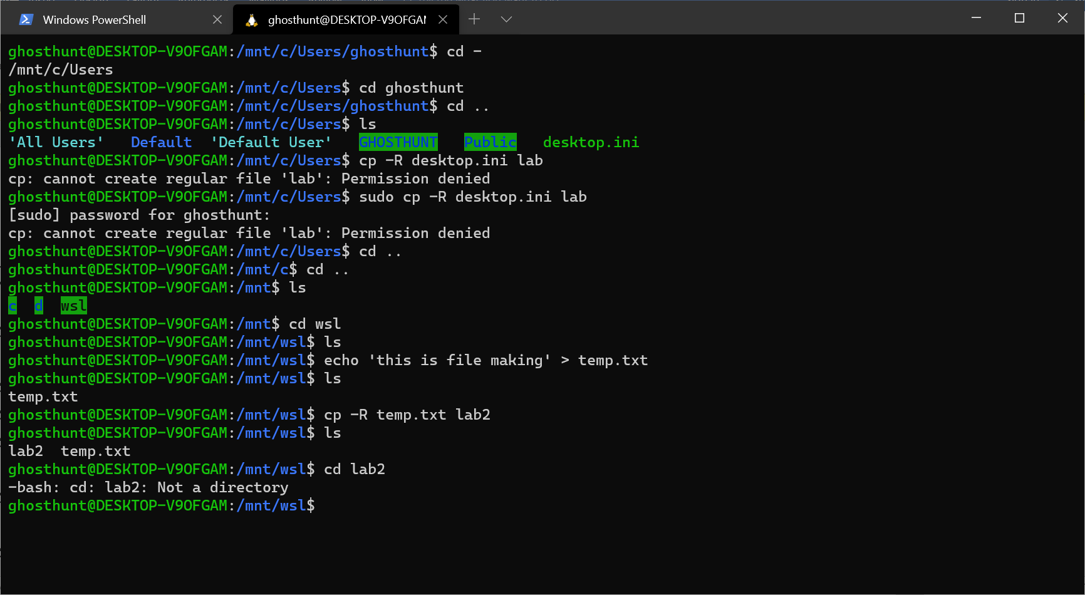

**cd**

cd is used for changing the directory of the working environment in the terminal

cd .. is used for going to the parent directory

cd – is used to display the current directory and going back

**cp**

cp is basically copying directory to another directory

cp -R copies the directory including its contents as well

**ls**

ls lists the file contents present in the current directory

ls -ls will display files in order

ls -l will display files along with its information

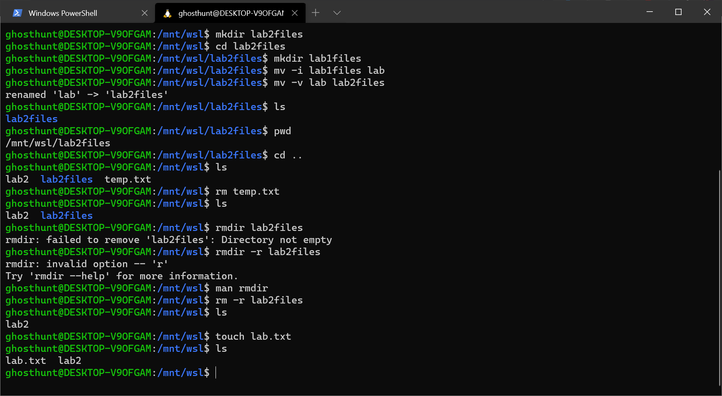

**mkdir**

mkdir creates a directory

mkdir -p will make a directory inside of another directory even if parent directories are missing

mkdir -m will enable us to set permissions on that directory

**mv**

mv will move a directory to another directory

mv -i will ask you when ever a file is being overwritten

mv -v will show what ever action is being taken place

**pwd**

pwd will show in which directory we are present

pwd -L prints the symbolic path

pwd -p prints the actual path

**rm**

rm removes the file

rm -f forces the file to be deleted

**rmdir**

mkdir are used to delete the directory

mkdir -p is used to delete the directory from any location

rmdir dir/sub dir remoives subdirectory first and then the director

**touch**

touch accesses the file if it doesn’t exist then it creates it

touch can change the access time of the file too

you can also create multiple files at once